|  |
| --- |
| Nextlifter.com |
| NextLifter Scoresheet Instructions |
| USAPL Contests |
|  |
| **Joe Marksteiner** |
| **1/18/2013** |

|  |
| --- |
| Scoring program for USAPL contests. |

Scoresheet Instructions (2015)   
  
Before you start practicing, save a copy of the program to a safe location!!  
  
Note: Some of the pictures may have come from a different version of the program and may not look exactly the same as the version you are working with.   
  
If you have problems or something isn’t working, please let me know so I can fix it. (it really helps if you e-mail a copy of the program you were using when it didn’t work correctly)

Contents

Dedication 3

Before loading the program 4

Excel 2003/2007/2010 4

Program Setup Page (start here) 5

Weigh-in Sheet 7

Spreadsheet Instructions 8

Basic Controls 8

First Group and First Attempts 11

Print Outs 12

Lifting 13

2nd & 3rd Attempts 15

Changing Flights or Groups 17

Bench Press 18

Deadlift 19

End of the Contest/Results 20

Results sheet 21

Awards 22

Clearing Data to Re-use the program 23

Some Notes on the Program 24

# Dedication

This program is free – it may be copied and shared with anyone. It is copyrighted because I wouldn't want somebody else to sell it. All I ask, is if you use the program and you like it that you consider a contribution in my daughter's name to the Little Star Foundation. You can find them on the web at

http://www.littlestar.org/

In January 2002 we lost our 16-year-old daughter - Liz Marksteiner - after a 16-month fight with cancer. She grew up around our Powerlifting family. While Liz never had any desire to lift, she was so proud of my wife and me when we were competing.

When Liz was old enough she almost always found a way to help out at the competitions - if she were here she'd be running this program. The summer before her death she spent a magical week at the foundation’s Silver Lining Ranch in the Colorado mountains she loved. The ranch is a retreat for kids with cancer and her time there meant so much to her and us.

Best of luck with the program.

Sincerely,

Joe Marksteiner

# 

# Before loading the program

I Excel 2016: Tryck på “Aktivera Innehåll” efter att du öppnat filen i Excel.

~~In Excel 2003~~

~~Change the security level~~

* ~~Click on~~ **~~Tools~~** ~~in the top of the screen~~
* ~~In the drop down~~ **~~Tools~~** ~~menu select~~ **~~Macro~~**
* ~~In the~~ **~~Macro~~** ~~dropdown menu select~~ **~~Security~~**
* ~~When the~~ **~~Security~~** ~~window pops up, choose~~ **~~Medium~~**

~~If you have more than one lifting session, you will need a copy of the program for each session.~~

~~Open the Excel file and save to your hard drive. Saving to a USB device may take 10-15 seconds and make it difficult to keep up with the contest~~

# ~~Excel 2003/2007/2010~~

~~To make the program work in Excel 2007 open the file and click~~ **~~Options~~**~~, then~~ **~~Enable~~** ~~this content when you see the security warning.~~

~~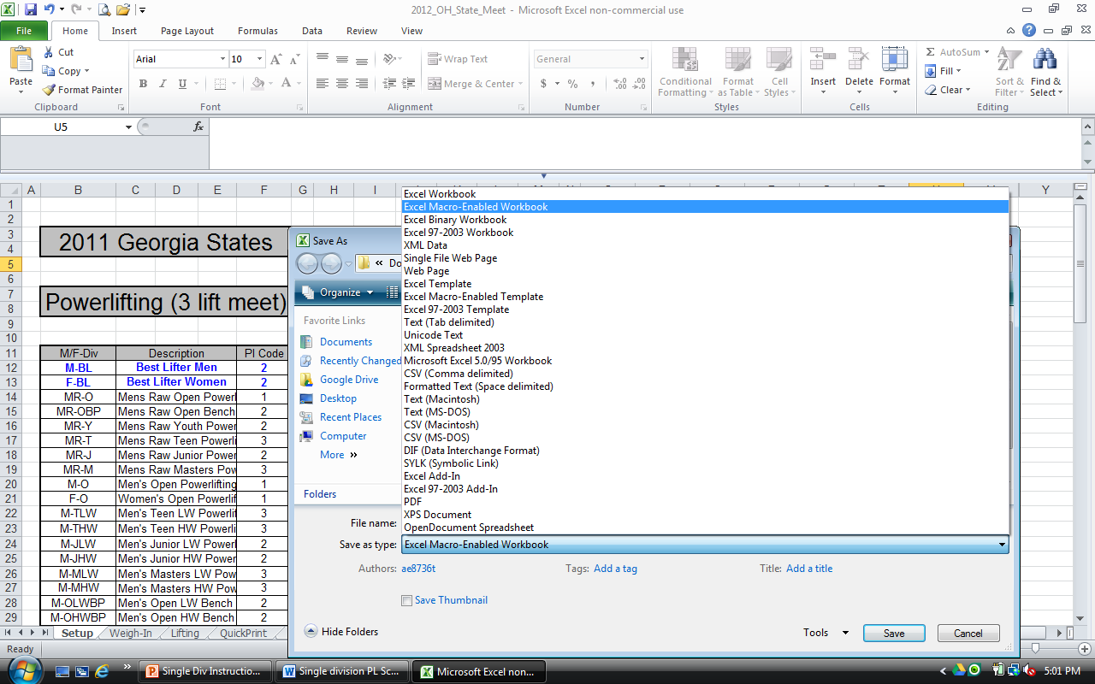~~

~~Then do a “~~**~~Save As~~**~~” an “~~**~~Excel Macro-Enabled Workbook~~**~~”. This will save the program in the Excel 2007 xlm format and preserve your original program file in the 2003 and earlier format. Obviously the 2007 xlm file now only works in Excel 2007. If the file gets corrupted it may not work correctly in any version of Excel.~~

# Program Setup Page (start here)

Type in the Meet Name in the cell outlined in the red box (the colored lines are not in the Excel file). It is automatically loaded into the print header for the results pages, the loading chart and into the title line on the Awards page.

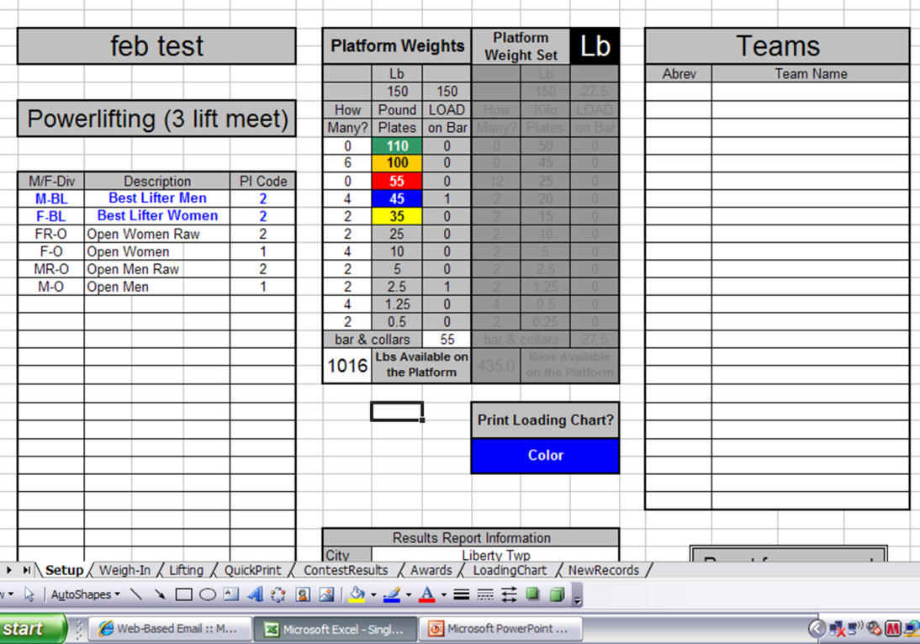

Select the type of meet from the pull down menu – click in the cell in the blue box above.

Fill in the Divisions you will have in your meet – green box. The first letter must be M or F for the Weight classes and Wilks Coeff to be computed. (Men and Women Best Lifter are preloaded)

Follow with a brief description like Men’s Open for the M-O division. Raw divisions are designated with “R” immediately after the gender (Example: MR-O for Men’s Raw Open lifters).

In the Pl Code column, select how each division will be scored

1. Div-WtCls-Total - Example: Men’s Open lifters will compete against each other based on Weight class and total.
2. Div-Wilks – Example: Female Open lifters will compete against each other based on their Total x WilksCoeff
3. Div-Wilks-Age – Example: Male Teen lifters will compete against each other based on Total x Wilks Coef x Age Coeff.

**Platform Weights** Select **Lb** or **Kg** from the dropdown list in the black block in the upper right corner depending on the platform weight set – it will hi-light the area for you to provide the data.

Select the weight of the bar plus collars from the dropdown menu.

**Teams** Type in an abbreviation for each team and the full team name. The abbreviations will appear in a pull-down menu on the Weigh-In sheet and the team name will appear with the lifter’s name on the **Lifting** sheet.

You can print a loading chart for the weight set on the platform. Select Color or Black & White from the dropdown list then click the **Print Loading Chart?** Block.

A caution note will pop up when you click the **Reset** button – select **OK** or **Cancel**.

# Weigh-in Sheet

The Weigh-in sheet is provided to make entering data easier and reduce the chances of overwriting or deleting something important on the Lifting sheet. You can type in any data that you have before the actual weigh-in. If you copy and paste from another file, use **Paste Special** then **Values** so you don’t lose the drop-down lists or the formatting.

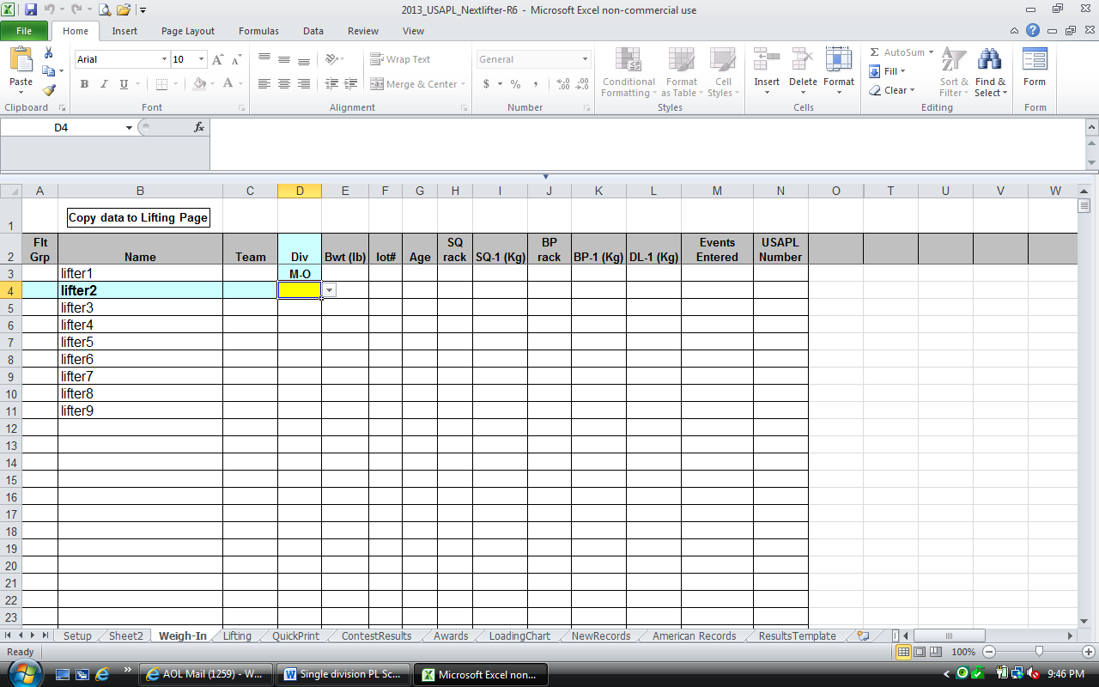

The program will accommodate 8 groups (A-H). Use the pull-down list in the **Flt Grp** column to assign those values. **Name** is self-explanatory. Use the pull-down lists for **Team** and **Div** – the lists will show the information you entered on the **Setup** sheet. Select **Bwt (lb)** or **Bwt (kg)** from the pulldown list in the block at the top of the body weight column. Then type in rack heights and opening attempts in the appropriate columns. If you don’t enter an age the program will assume the lifter is not eligible for the men’s 114 class or women’s 97 class and will not compute an age coefficient.

Lifters in Multiple Divisions - If you have a lifter entered in multiple divisions he/she will need a separate line for each division. Just assign the same lot number and first attempts. A lifter can also enter the 3-lift meet in one division and the BP in another – in that case leave the SQ and DL opening attempts blank on the BP only line.

Type in the codes for the **Events Entered**. Use the codes provided in the information box on the sheet. Make sure you enter UPPER case letters **PL, BP,** etc. (the codes must be UPPER CASE characters).

Lifters in Multiple Events - A lifter can enter multiple events – just indicate in the Events Entered column. So, a lifter in the 3-lift and bench comps would have **PL BP** in that column (the codes must be UPPER CASE characters).

Do not leave any blank rows between lifters on the **Weigh-in** sheet.

When you’ve finished entering all the weigh-in information, click the **Copy Data to Lifting Page** box at the top and it will move all the lifters who have weighed in to the **Lifting** sheet. If you have more than one session, just assign different groups or flights to the lifters in the second session. When you click the button for the second session, it will move the first session down to make room on the **Lifting** sheet.

# Spreadsheet Instructions

The screen is divided into 2 basic areas – the Current Attempt Area (above the gray bar with column headings Flt, Name, Team, etc.) which shows the information for the lift being performed on the platform. Most of your actions during the meet will be in this area. The only thing you do in this area is mouse click – Don’t try to type anything here!

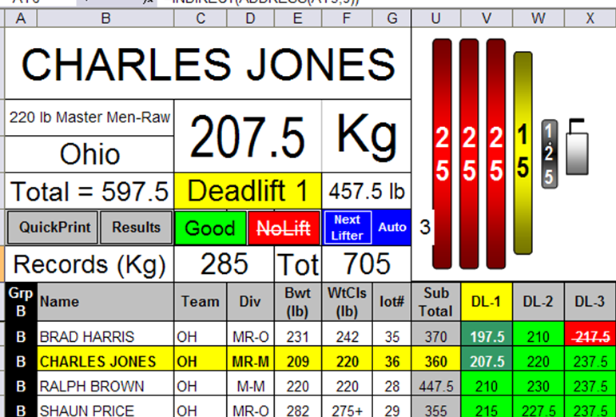

Current Attempt Area

Scoresheet Area

The Scoresheet Area has the data you entered at weigh-in and records the Good/No-Lift information from the Current Attempt Area. You also enter next attempts here during the meet.

~~A timer (I use the Xnote Stopwatch program available on the web) can be added to the sheet in any open area. Don’t delete any columns or cells or type in the gray areas of the screen – it will probably disable the macros.~~

~~You can also use the Excel zoom and full screen controls as necessary for the best display.~~

# Basic Controls

Name pulldown – this list displays the names of the lifters in the group at the top of the lifting order - you can select any lifter in the current group from this list. The lifter’s name will be highlighted in yellow in the scoresheet area.

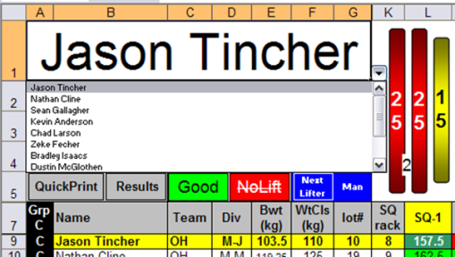

Attempt pulldown – select the current attempt from this list. When you select **Squat 1**, **Bench Press 1** or **Deadlift 1**, the program sorts the opening attempts in all the groups. When you select 2nd, or 3rd attempts it only sorts the group at the top of the lifting order. The column header for this lift will be highlighted in yellow in the scoresheet area.

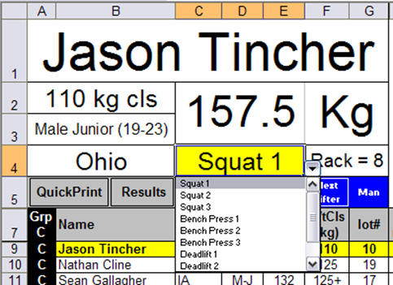

**Good** and **~~No-Lift~~** buttons – tell the program if the current lifter’s attempts (selected with the Name and Attempt pulldowns) was passed by the refs or turned down. They change the color of the weight on the bar – Green for **Good** and Red for **~~No-Lift~~**. These buttons also update the Best Lift value that goes into the lifter’s total. The **Next Lifter** button advances to the next lifter in the group (if you are at the end of the current group it doesn’t do anything). If you select “Auto” the program will automatically advance to the next lifter when you click **Good** or **~~NoLift~~**. Select “Man.” from the pulldown during 3rd attempt deadlifts or when attempt changes may change the lifting order.

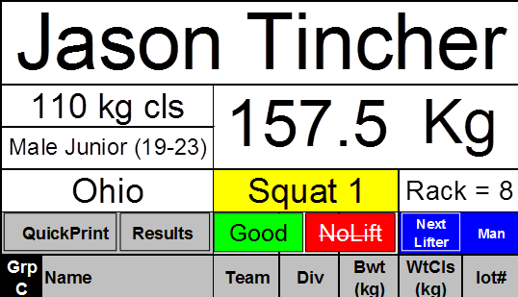

If you need to make an attempt Good or No-Lift for a lifter that is not on the platform (making a correction or “playing catch up”), click on the attempt you need to change in the scoresheet area and press

* **Control** key and the **G** key for a **Good** lift
* **Control** and the **N** key for **No-Lift**

This will update the scoresheet section of the page but not affect the current attempt section.

The Changing Groups pulldown moves the selected group to the top of the lifting order. Then select the Squat 1, Bench Press 1 & Deadlift 1 as appropriate in to sort the opening attempts correctly for the new group and put the first lifter in the name block at A1.

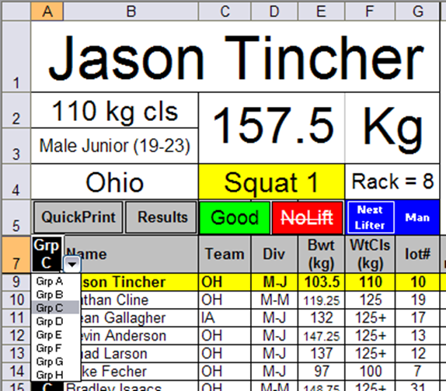

If you need to add a lifter, select **New Lifter** from the attempt pulldown. A new line will appear at the bottom of the name list – fill in all the necessary information starting with group and going all the way to Pl Code (column AC).

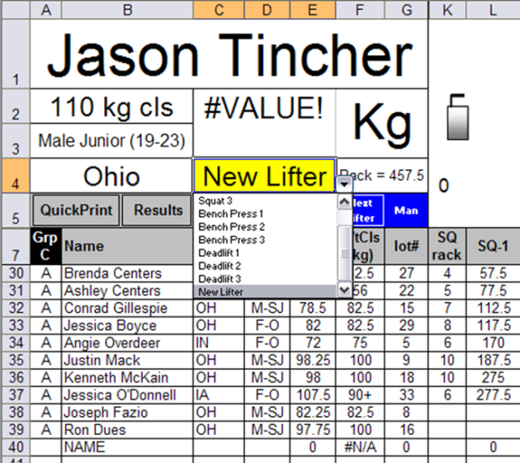

Then select the correct group from the Changing groups pulldown and the correct lift from the Attempt pulldown list

# First Group and First Attempts

After you transfer the Weigh-In data to the Lifting sheet:

1. Select your first group from the drop-down menu

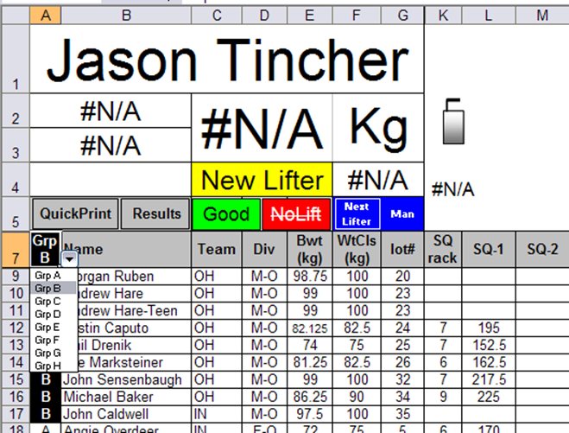

Selected **Squat 1**, **Bench Press 1**, or **Deadlift 1** from the attempt pulldown as required

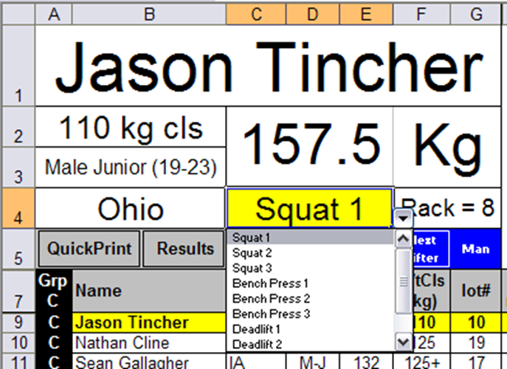

Check for the correct lifting order and the name of the first lifter in the name block.

# Print Outs

After all the weigh-in information is loaded – and the sheet is sorted for the first group you can click the **QuickPrint** button and print out a scoresheet for the Jury table and a one for manual backup at the score table. The **QuickPrint** and **ContestResults** sheets are formatted for easier printing.

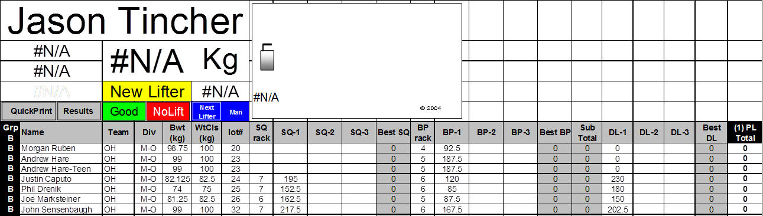

The Meet name from the **Setup** sheet should already be in the header. You can hide/unhide columns but don’t delete any. (Go to the **QuickPrint** and **ContestResults** sheets and set the margins, etc. – you may need legal paper to display all the information you want.) Once it is configured properly you can produce a printout of the current sheet any time you want by clicking the **QuickPrint** button on the **Lifting** sheet. Don’t use this feature if you don’t have a printer connected to your computer.

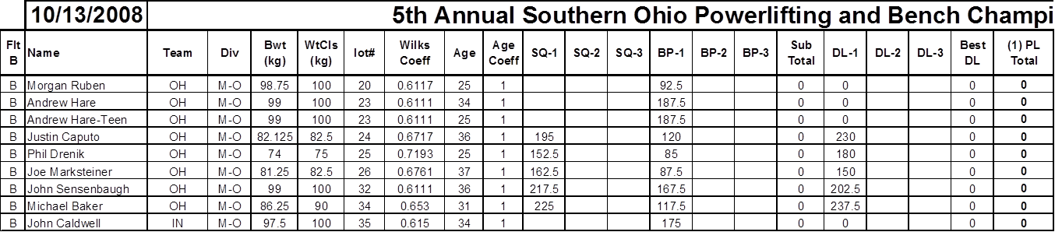

QuickPrint skriver ut ett protokoll för den aktiva gruppen.

# Lifting

Return to the **Lifting** sheet and Let the lifting begin!

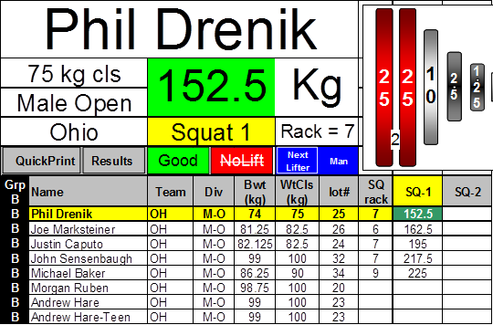

If the 1st lifter is successful on his attempt, click on the green **Good** rectangle, if not click on the red **~~No-Lift~~** rectangle.

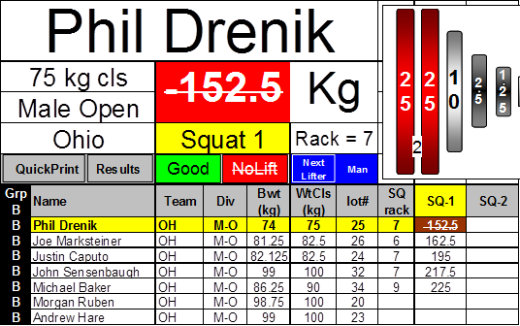

A **Good** lift will change the color of the Weight blocks to green and a **~~No-Lift~~** will change the color to red. It also updates the information in the scoresheet area. If “Auto” is selected in the box next to the

**Next Lifter** button, the program will automatically advance to the next lifter.

Click the blue **Next Lifter** button if necessary or select from the pulldown list in the name block if necessary. The names in the pulldown will be in the same order as the names in the name column in the scoresheet area. The program will display the new lifter’s information. Continue through the Squat 1 attempts choosing the lifter then selecting **Good** or **~~No-Lift~~**.

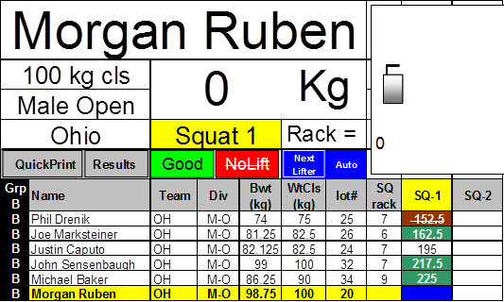

If there is a loading or spotter error and the lifter is granted another lift at the end of the round, just type in the correct weight and the cell should turn white indicating that this lift has not been taken. Come back to him/her at the end of the round using the pulldown list in the name block.

If you need to make an attempt Good or No-Lift for a lifter not on the platform, click on the attempt you need to change and simultaneously press:

* **Control** key and the **G** key for a **Good** lift
* **Control** and the **N** key for **No-Lift**

## 2nd & 3rd Attempts

Lifters will be turning in their 2nd attempts and they can be entered in the **SQ-2** column

When you enter the next attempt, the scoresheet will automatically sort itself so the next round attempts are in the correct lifting order. It will not change the order for the lifters waiting to lift in the current round.

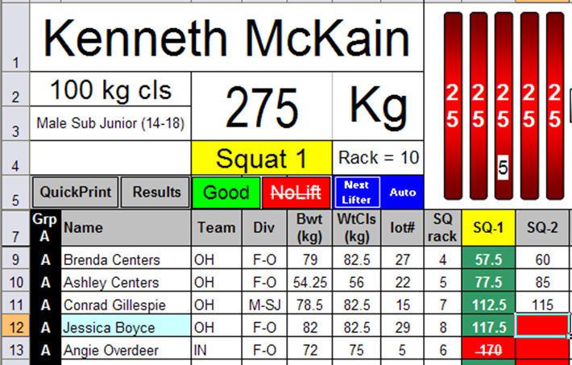

If the cell for the next attempt turns red, it has been more than a minute since the previous attempt was entered as a **Good** or **~~NoLift~~**.

The comments in the best lift column for squat, bench and DL will show a history of the lifts with the associated time when attempts were entered/changed and **Good**/**~~NoLift~~**. The history appears when you place your cursor over the cell.

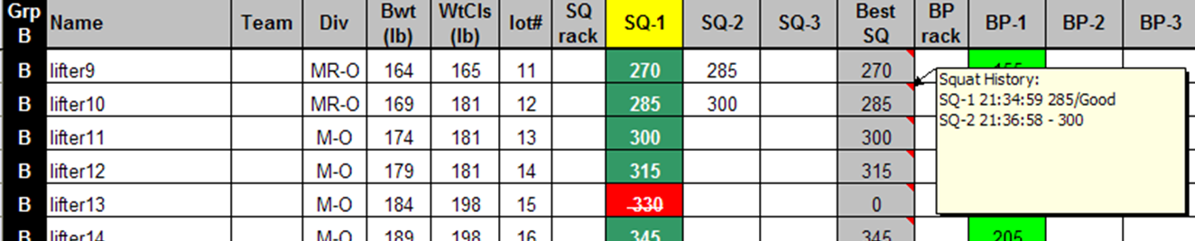

After all the 1st squats are complete for the first group, Select **Squat 2** from the attempt dropdown.

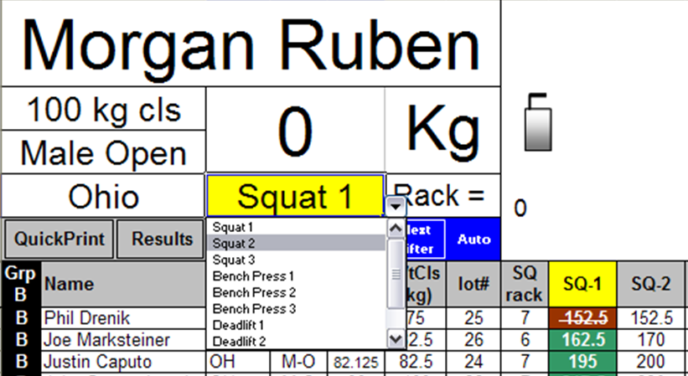

The program will sort the 2nd attempts for the group at the top of the order and put the first lifter in the name block.

There will be a short delay as the program saves and uploads to the internet if you are set up to do that.

Assign **Good** or **~~No-Lift~~** to the 2nd attempts the same way as first attempts. Do 3rd attempts the same way.

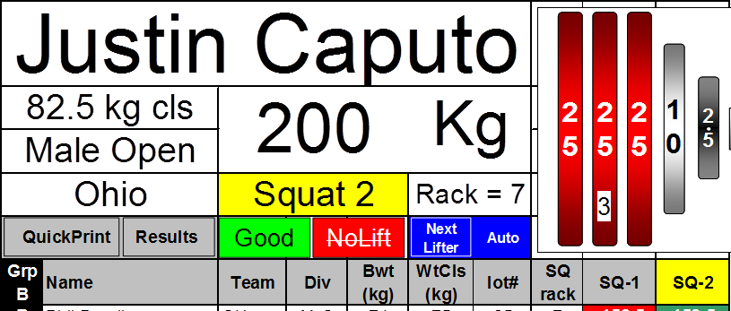

If lifters from the next group have changes for opening squat attempts, simply enter them in the correct location and the program will update the lifting order.

## Changing Flights or Groups

At the end of Squats for the first group:

Select the next group to lift from the group pulldown – This will move the new group to the top of the lifting order

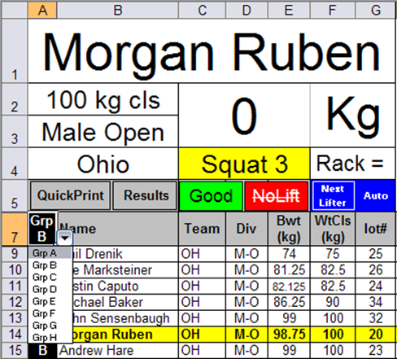

Select **Squat 1** from the attempt dropdown - This will sort the Squat 1 attempts for the new group and put the first lifter in the name block.

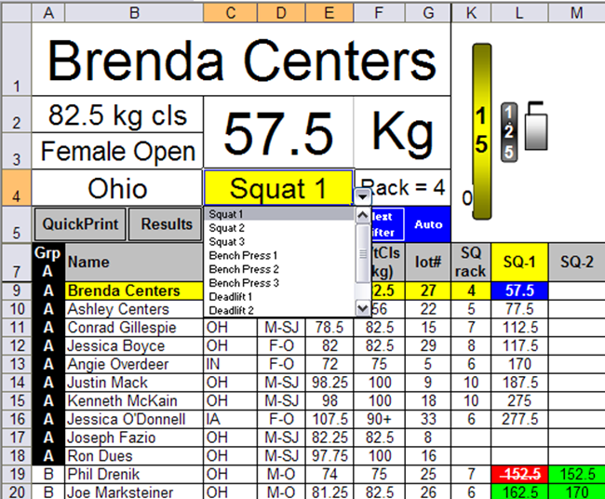

The next group is now ready to go – choose **Good** or **~~No-lift~~**

Select the next lifter and enter next attempts the same way as before.

Follow the above steps for the remaining groups of Squats.

## Bench Press

If there are changes to opening bench attempts just enter them and the program will sort them correctly – you don’t need to change the group, the attempts or the lifter to update the next group’s bench order.

When you are done with Squats start with the first groups bench press.

Select the first group to bench from the list at the top of the group column.



Select **Bench Press 1** from the pull-down below the name block

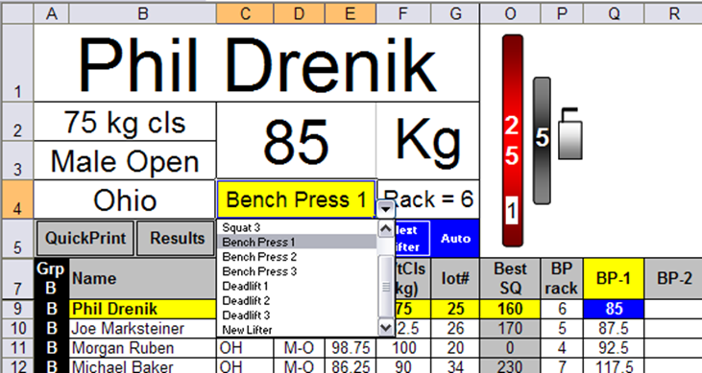

Use the **Good** or **~~No-Lift~~** buttons as appropriate – the lifters’ Sub Totals will automatically update

Select **Next Lifter** or use the pulldown list in the name block.

Proceed through Bench the same way you went through Squats.

## Deadlift

If there are changes to opening Deadlift attempts just enter them and the scoresheet will automatically update the lifting order.

When you are done with Bench start with the first group to Deadlift.

Select the first group to deadlift from the list at the top of the group column.

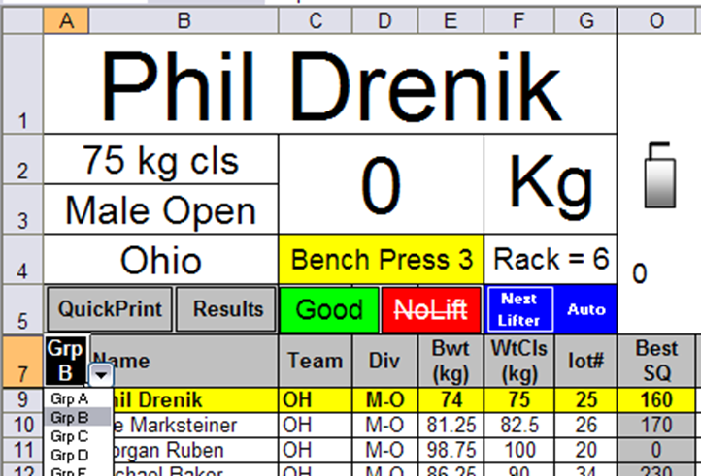

Select **Deadlift 1** from the pull-down below the weight block

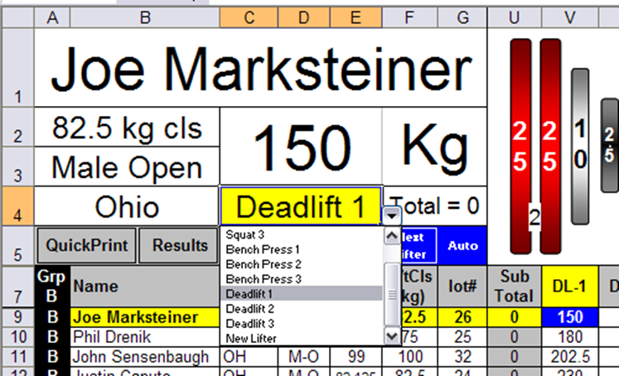

The first lifter should be in the name block.

The data for the first lifter in the next group to Deadlift will appear in the current attempt area.

# End of the Contest/Results

Proceed through Deadlift the same way you went through Squats and Bench using the pulldowns to select the group, the lifter and the attempt.

During 3rd Deadlifts you can change **Next Lifter** Auto to Man so you can make changes to 3rd attempts before the program advances.

Select **Good** or **~~No-Lift~~** for each attempt. After each successful Deadlift, the lifter’s **Total, Wilks Total, Age Coef x Wilks, and PL-Div-WtCl-Evt** are computed automatically and updated (if this column is empty, ensure the Lifter’s division and weight class are valid and that valid codes are in the **Events Entered** column).

When people change 3rd attempts on deadlift just enter the new attempts in the correct location and the program will automatically re-compute the lifting order.

At the end of Deadlift, click on **Results**, the program will arrange the lifters by Division, Weight Class and Total. This button also runs or re-runs the scoring macros for all the individual events.

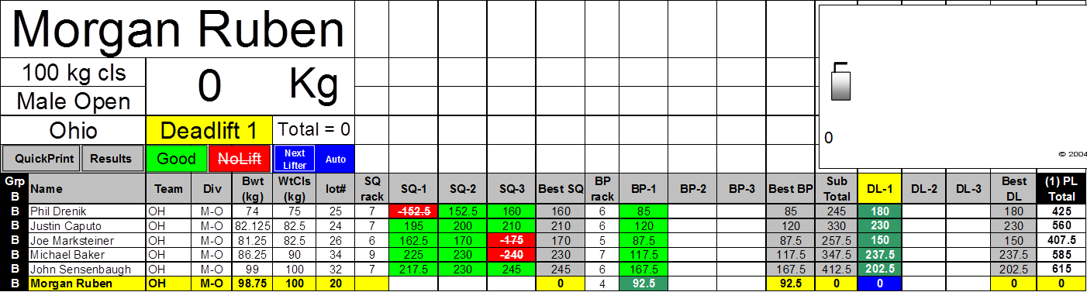

The **QuickPrint** button copies the data to the **Results** sheet that is formatted for easier printing and copying.

## Results sheet

The **ContestResults** sheet is formatted for easier printing. All the data from the Lifting sheet is transferred to this sheet but may be in a hidden column. You can hide (do not delete) or unhide columns as necessary to show the information you want or to fit the paper in your printer.

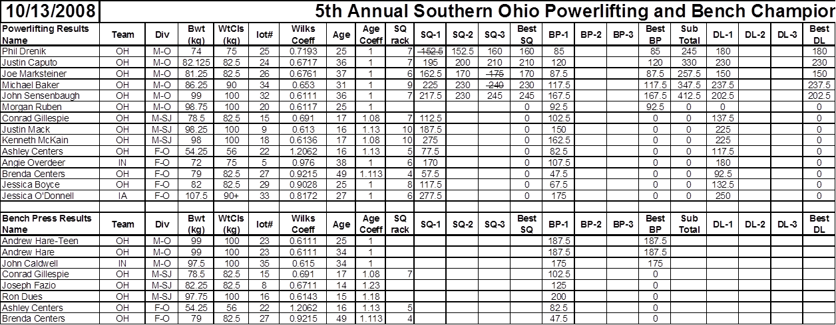

Results will usually fit on letter paper in landscape mode. You may need to use legal size paper if you want to display more columns. Do a test print to make sure you margins, headers & footers etc. are correct.

You may hide columns but don’t delete any columns on this sheet if you are going to use the program again, otherwise the information from the **Lifting** sheet won’t be in the right columns.

You can use the Excel Auto Filter functions to display a particular weigh class or division.

# Awards

This page displays up to 5 lifters/places in the selected Divisions/weight classes at the end of the meet.

Select the award categories (Division, Weight Class and Event) by clicking on the underlined text and selecting from the dropdown list. The divisions are the same ones you entered on the **Setup** sheet – these are the only inputs you make on this sheet.

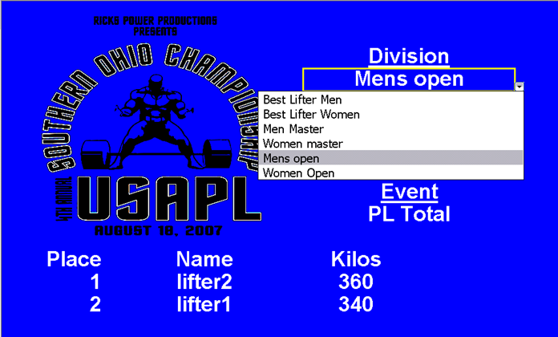

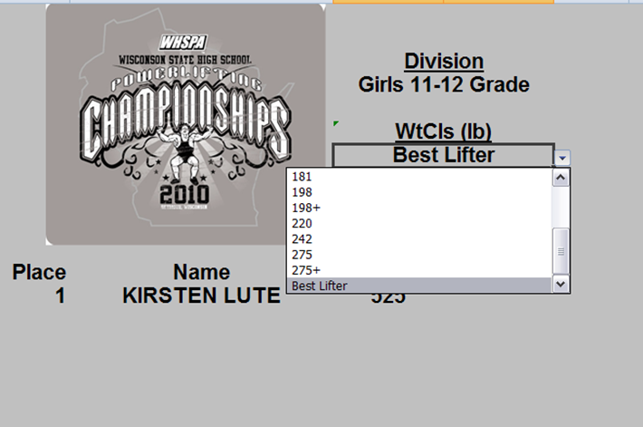

You can use the Excel Full Screen and Zoom functions for the best display. You can also resize columns or rows (don’t delete any) to fit your display and you can change the background or add your own meet graphic to the page (just unprotect the sheet). It’s OK to change the text font/size and cell colors too.

# Clearing Data to Re-use the program

Make sure you save your file or you may lose all your data.

Go the **Setup** sheet and click on the box that says:

**Reset for New Meet**

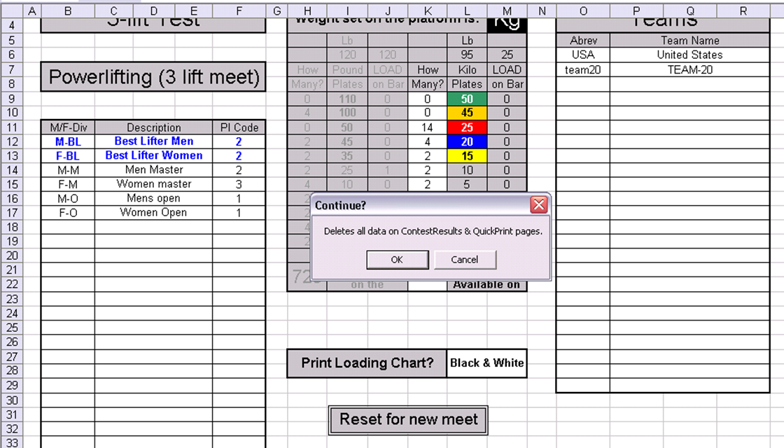

A series of message boxes will pop up asking which sheets/data you want to clear. Click **OK** or **Cancel** as appropriate. (If you are running a practice contest you may not want to clear the **Weigh-In** and **Setup** sheets.)

# Some Notes on the Program

Someone familiar with Excel can easily hide/unhide columns and resize the display as necessary. They should also be familiar with print commands and formatting.

When you click on **Good** or **~~No-Lift~~** it may take several seconds for the macros to run and make all the changes to the spreadsheet – it takes longer if you have a slow processor.

VIKTIGT:  
**It’s a good idea to practice with the program before the meet to get used to the sequence of doing things (start with a blank Weigh-in sheet and simulate a whole meet including print out of the results).**

The program saves automatically every time you change attempts (like changing from **Squat 1** to **Squat 2**). If it crashes you should be able to open a file that still has most of your contest information.

~~I did not build in a timer – I found Xnote Stopwatch (http://www.stopwatch-timer.com/) to work well for PL meets. It has an easy to use countdown timer and it can be resized and placed in any open area of the sheet. I recommend setting up hotkeys to run the clock (I use F1=start/stop and F2=Reset) it saves mouse clicks switching from the timer to the scoresheet.~~

* Ctrl + U startar klockan
* Ctrl + I stoppar klockan
* Ctrl + J klickar på Good
* Ctrl + K klickar på No Lift
* Ctrl + Q (in)aktiverar fullskärm för det aktiva bladet
* Ctrl + W öppnar det aktiva bladet i ett nytt fönster